JOE REEVES

Joe first moved to the north from London in 2012 to study BA Music at the University of Leeds. He has since completed a Choral Conducting Scholarship at Leeds Cathedral of St Anne and has been freelancing for the past three years. Alongside private piano students, his work includes: Lead Musician for Yorkshire Dance’s project In Mature Company; an initiate in care homes to combat loneliness for those living with dementia; Workshop Practitioner for the Leeds Playhouse Youth Theatre; and Musical Director for various companies, including taking an original musical to the Edinburgh Fringe Festival in 2017. He became conductor for The Wendel Singers in 2018 after the retirement of Joe Roberts.
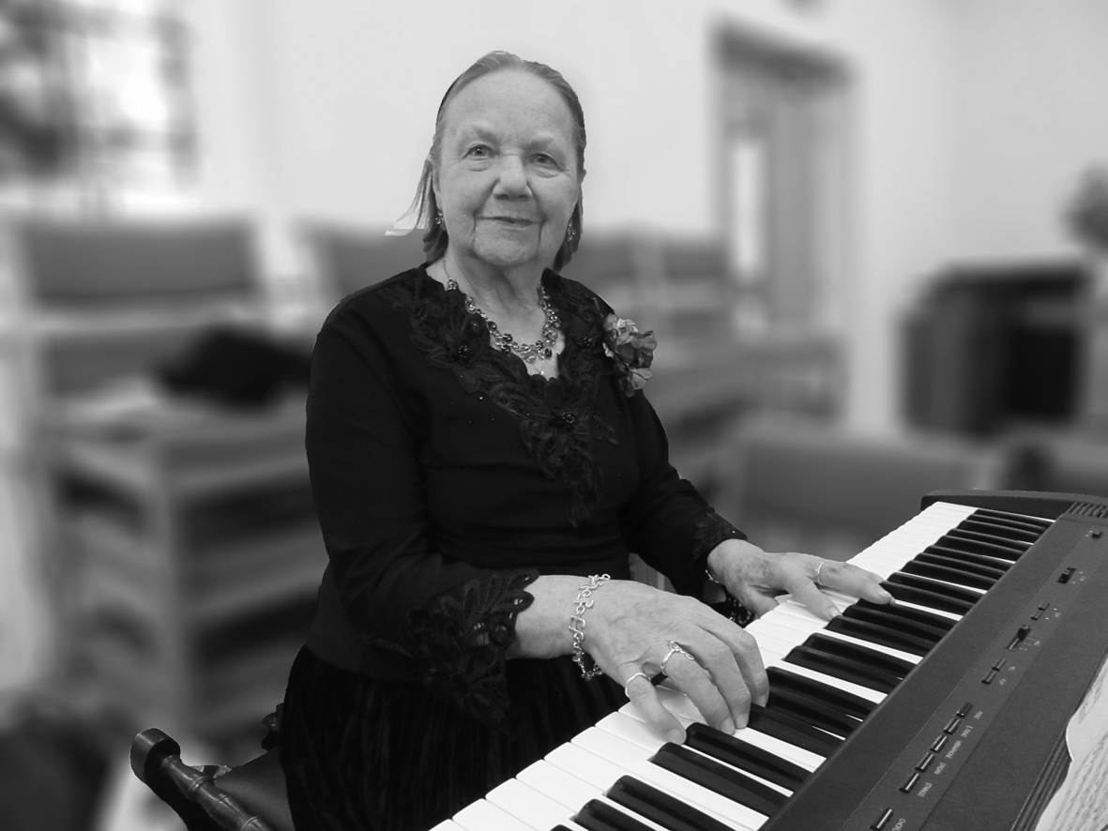
BRENDA KNOWLES

Brenda, our accompanist for about ten years, has been playing the piano since she was six and loves making music. She is the organist at St Mary’s Parish Church, Swillington, and also plays for the Garforth Musical Society and White Rose Male Voice Praise.

THE WENDEL SINGERS

The Wendel Singers originated as the Barwick-in-Elmet Townswomen’s Guild Choir. After 1974 it became the Elmete Singers, still a women’s choir, which competed in the Pontefract Music Festival as well as performing concerts. In 1980 it became The Wendel Singers, taking its name from Wendel Hill, the site in Barwick of an iron age hill fort and later a Norman castle.

Over the years it has had a number of conductors, including Adam Tomlinson (now at Radio York), Forbes Doig, David Fligg and Glenys Heywood. Around 2006 its number had dwindled to single figures, but it gained a new lease of life when Joe Roberts took over as conductor and brought in new members, building our strength to more than 30 singers.

In all those years the choir has practised every Wednesday evening in the Barwick-in-Elmet Methodist Church schoolroom. We sing a great variety of four-part choral music, mainly short pieces, ranging from renaissance to contemporary, both religious and secular, just for the sheer pleasure of being together making music, performing occasional concerts.

We hope to continue to grow and flourish under our new conductor, Joe Reeves, who has already led us to a performance that gained a merit in the 2019 Rothwell Music Festival.
Harmony & Humour—A Bit of This and That

by The Wendel Singers
Conductor: Joe Reeves
Accompanist: Brenda Knowles

Barwick-in-Elmet Methodist Church

Friday 18th October 2019
at 7.00pm

Programme

Part 1

Fanfare (Martin Shaw)
A Whole New World (from Walt Disney’s Aladdin)
(Alan Menke & Tim Rice)
The Bare Necessities (from Walt Disney’s The Jungle Book)
(Terry Gilkyson, arr John Leavitt)

Interlude: Christine Nottingham recites Their Way? No Way! (Anon)
Stan Pearson If Noah Had to Build the Ark Today (Anon)

Loch Lomond (Ralph Vaughan Williams)
The Water of Tyne (W.G. Whittaker)

Interlude: Brenda Knowles: Piano solo Humoresque (Anton Dvořák)

Look to the Day (John Rutter)
Look at the World (John Rutter)

Interlude: Gill Sinclair: Children’s poems Spike Milligan

A London Medley (George & Ira Gershwin, Manning
Sherwin /Eric Maschwitz, Irving Berlin, arr. A. Kyle)

INTERVAL

Part 2

View Me Lord (Thomas Campion & Richard H. Lloyd)
The Lily of the Valley Afro-American Spiritual
(arr. Wendell Whalum)

Interlude: Bev Kelly sings Stately as a Galleon (Joyce Grenfell)

Something Told the Wild Geese (P. Black arr. B.D. Hawer)
Steal Away to Jesus (Arr. Hugh S. Roberton)

Interlude: John Summerwill: A Bit of This and That

Broadway Blockbusters: (Arr. Mark Brymer)
Sun and Moon (from Miss Saigon)
Do You Hear the People Sing? (from Les Misérables)

